Bampton and District Local History Society

The Iron Crown?
Fingerposts in Cumbria

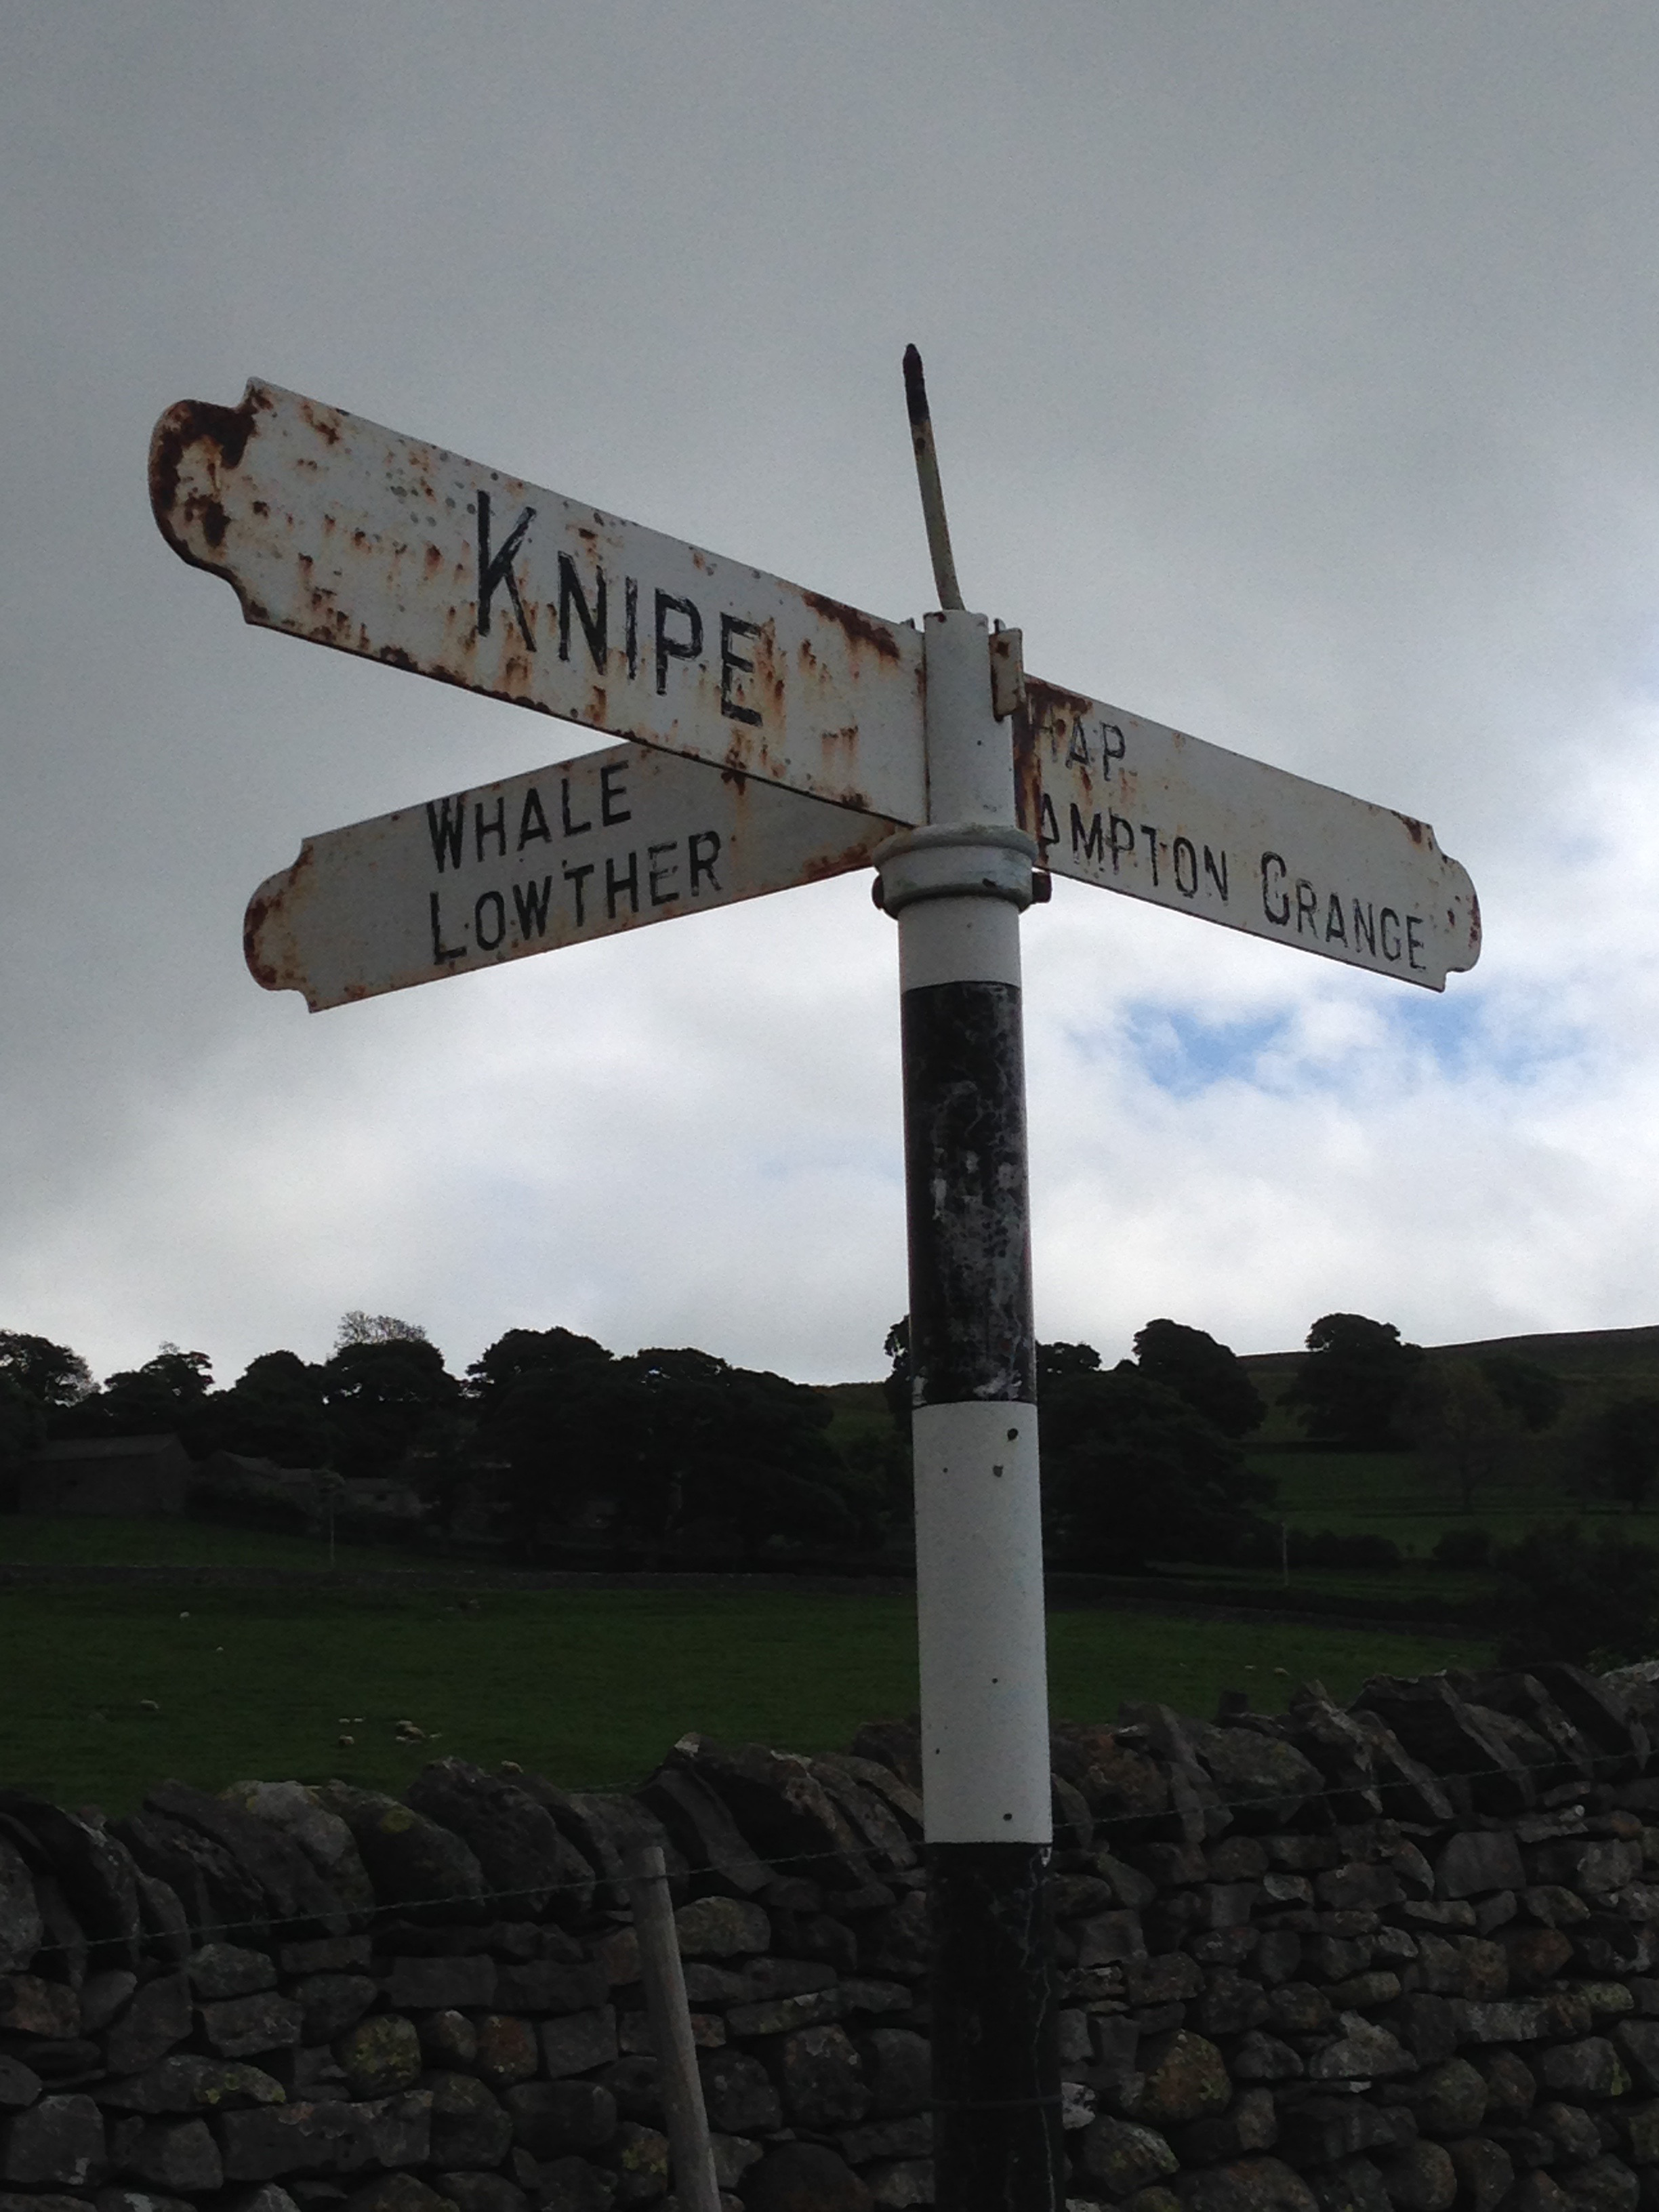

Mike and Kate Lea

Tuesday 7th March
7.30pm

Bampton Memorial Hall

Everyone welcome!
Refreshments will be served
Members £1 Visitors £3

